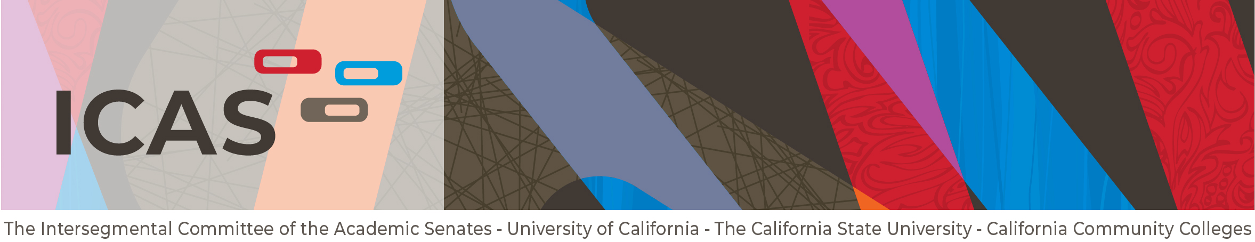

May 31, 2023

Agenda Item 5: Establishing a Task Force to provide recommendations for determining Program Duplication

Action: Discuss and consider forming a Task Force to provide recommendations for determining Program Duplication

Background

On May 3, 2023 the ICAS chair received the following request from the CCCCO:

Leaders from the CA Community Colleges Chancellor’s Office (CCCCO), the CA State University Chancellor’s Office (CSUCO), the University of California Office of the President (UCOP), and the Association of Independent California Colleges and Universities (AICCU) have engaged in a number of conversations about the implementation of Assembly Bill 927 (AB 927), CA community college baccalaureate degree programs (BDP). As [the] segments of higher education work together to establish clear processes and procedures for the review of proposed community college BDPs, we are working to establish an agreed upon set of program duplication criteria and standards and believe it is essential we engage faculty in these important conversations. Toward that end, we are requesting the Intersegmental Committee of the Academic Senates (ICAS) establish a special group, inclusive of AICCU faculty and systems’ office representatives, to present a recommendation for
- A definition of program duplication,
- A set of program duplication criteria (i.e. what components of a program should be examined and compared), and
- A program duplication standard (i.e. how much or what percent of similarity determines program duplication).

During the ASCCC 2022 Fall Plenary Session, the ASCCC delegates passed resolution F22 15.05 which called for:

Resolved, That the Academic Senate for California Community Colleges work with leaders of the University of California Academic Senate and Academic Senate of the California State University through the Intersegmental Committee of Academic Senates (ICAS) to advocate for a definition of duplication that includes consideration for local unmet workforce needs, regional rather than statewide duplication, and potential impact on place-bound students while acknowledging the different roles and philosophical intentions of each system’s baccalaureate degrees, including in preparing students for careers, post-graduate education, and on-going research.

